CITI REGISTRATION INSTRUCTIONS
BASIC COURSES
REFRESHER COURSES
TO OBTAIN A COPY OF YOUR COMPLETION REPORT

BASIC COURSES
- Go to citiprogram.org
- Click on Register
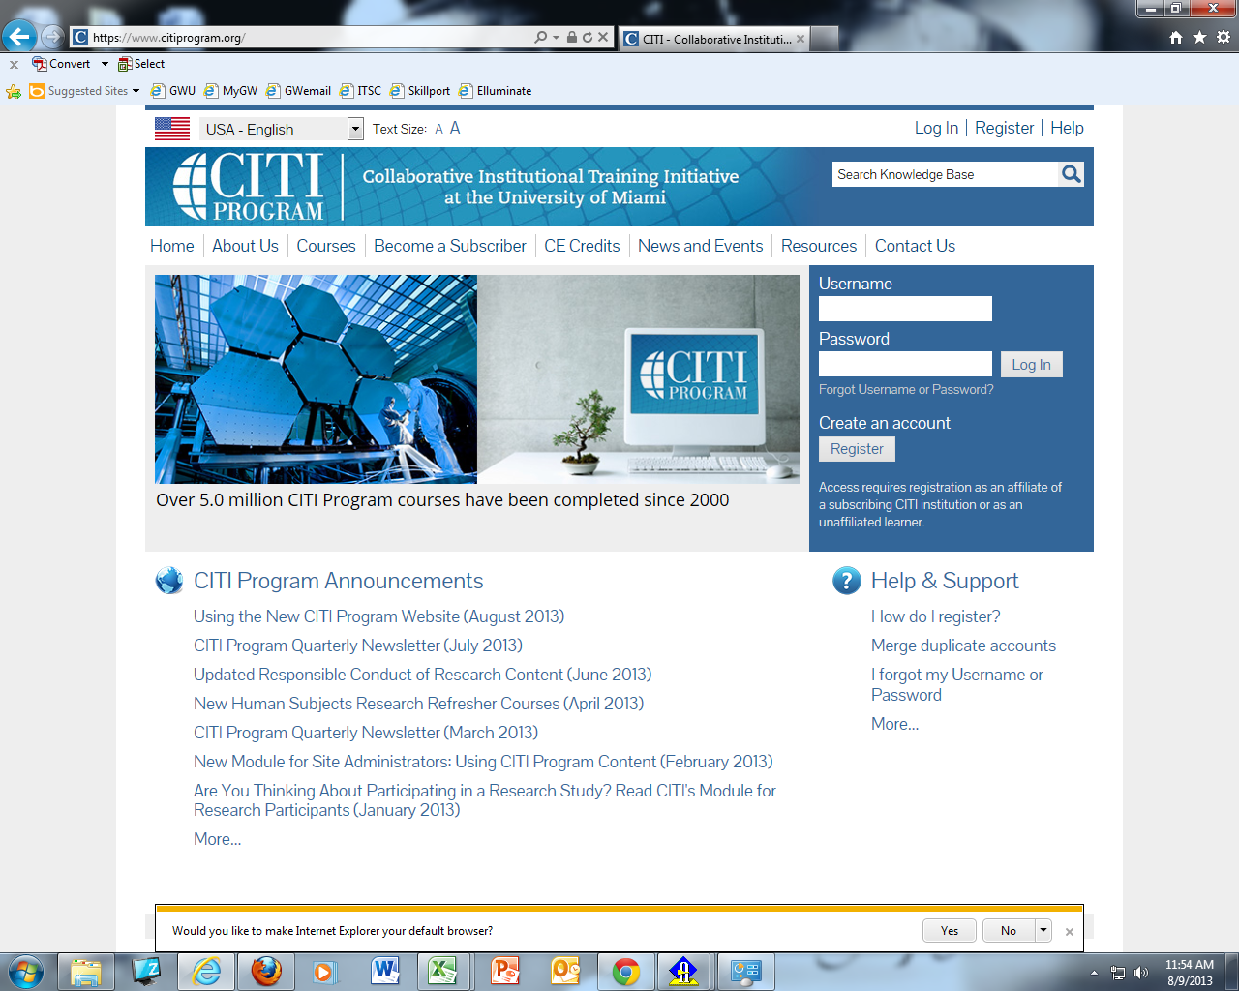

- Fill in the requested information
  - Select George Washington University as your institution
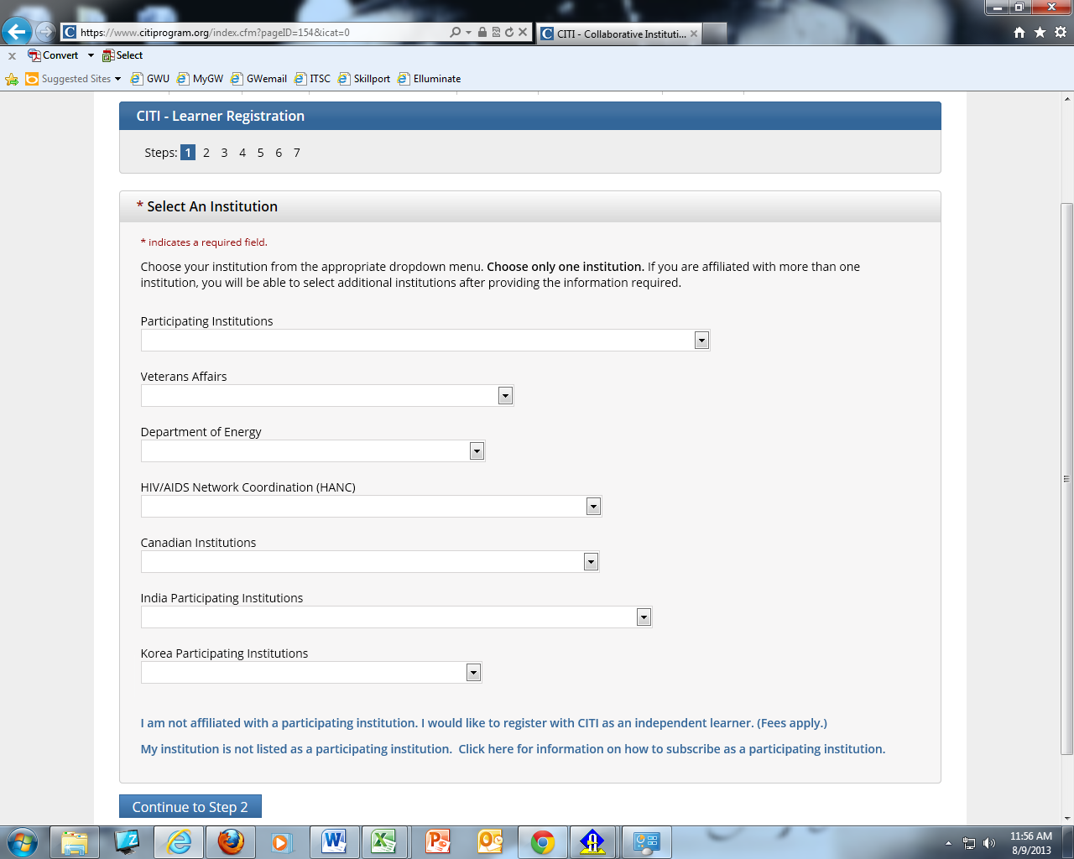
George Washington University

- Fill in the rest of the information as it pertains to you

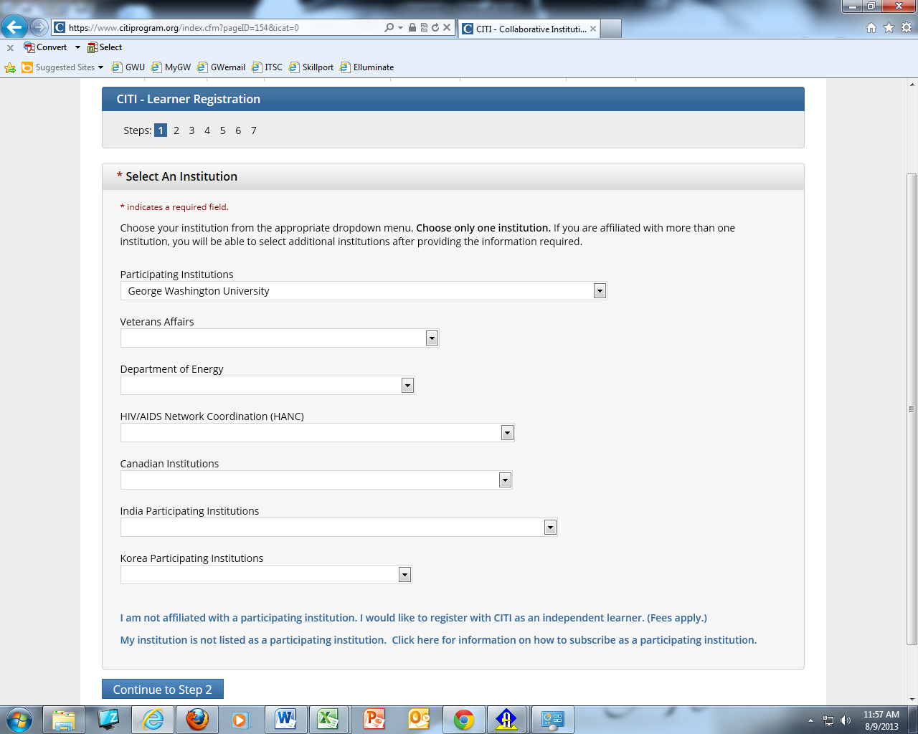

- Complete your information
  - You will need to provide two email addresses
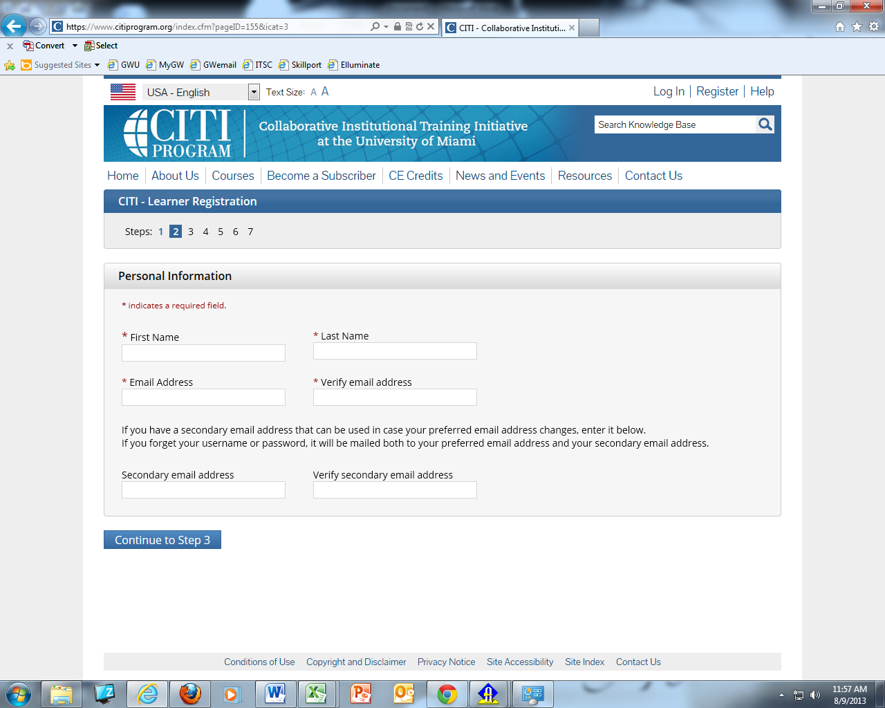

- Please create a username and password.
  - You will need to save this information somewhere for easy retrieval- OHR will not have access to it to provide for you

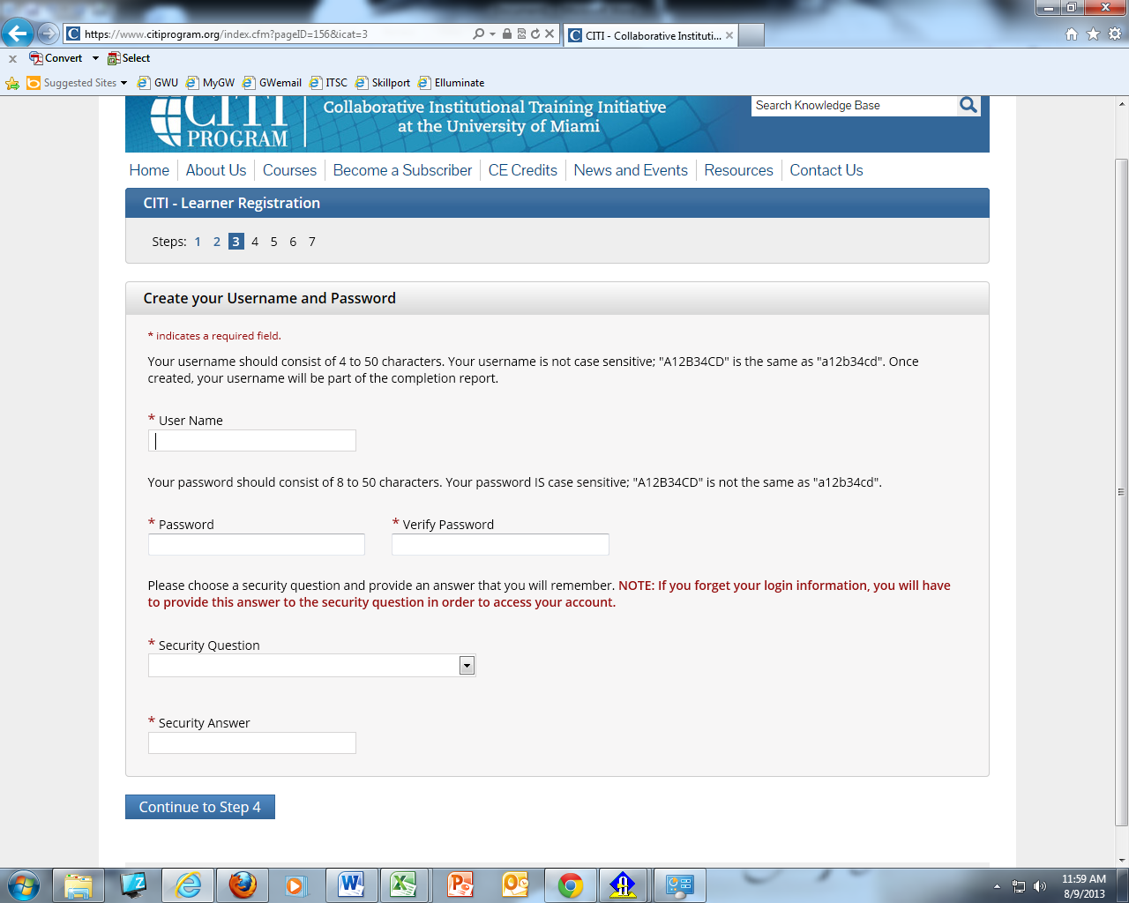

- Fill in your information
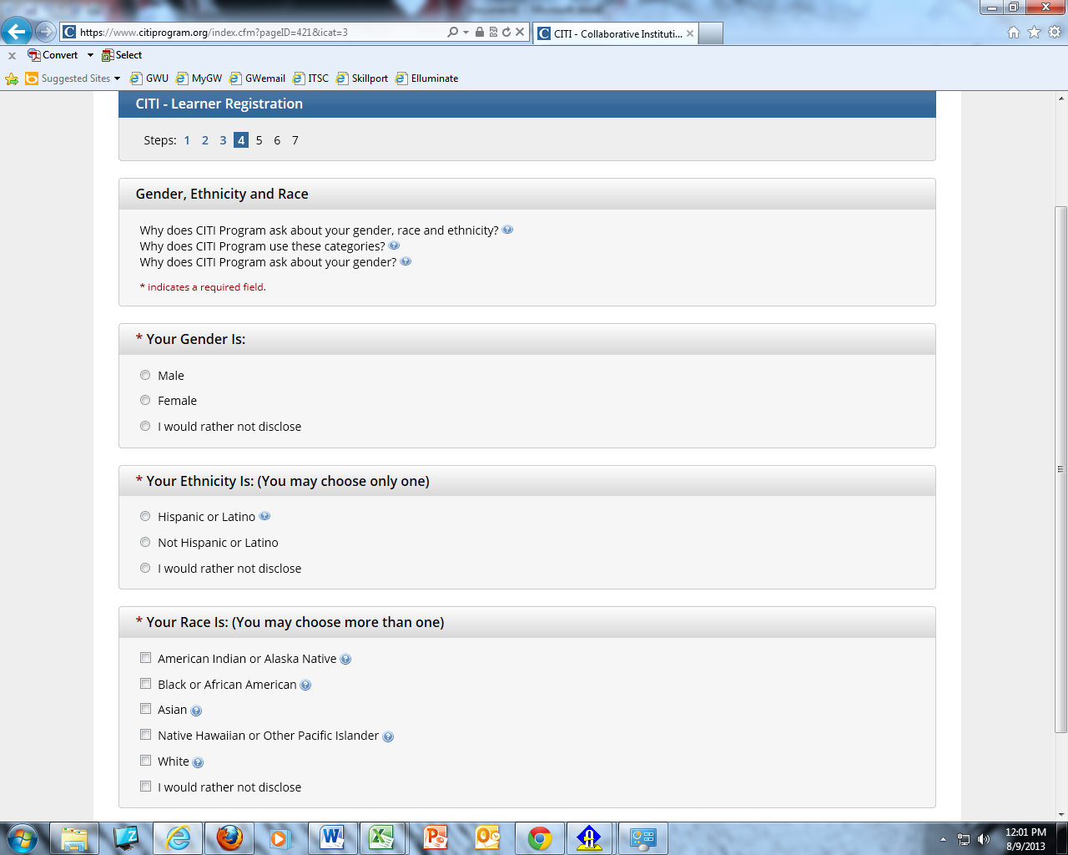

7a. Continue filling in the information
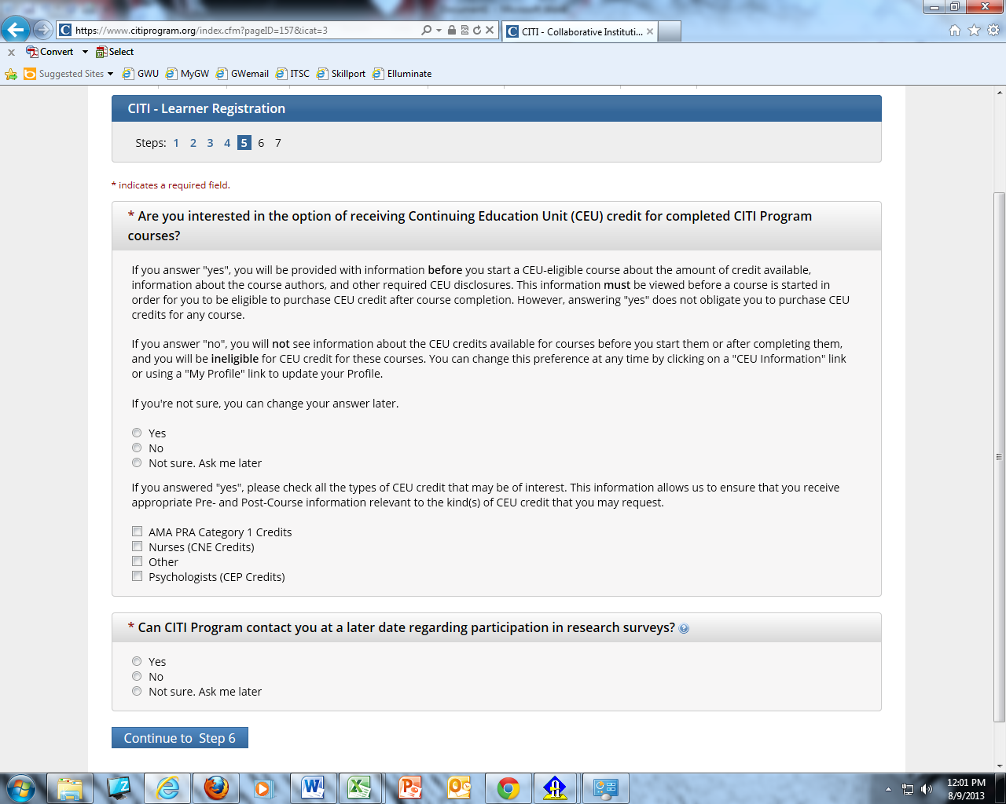
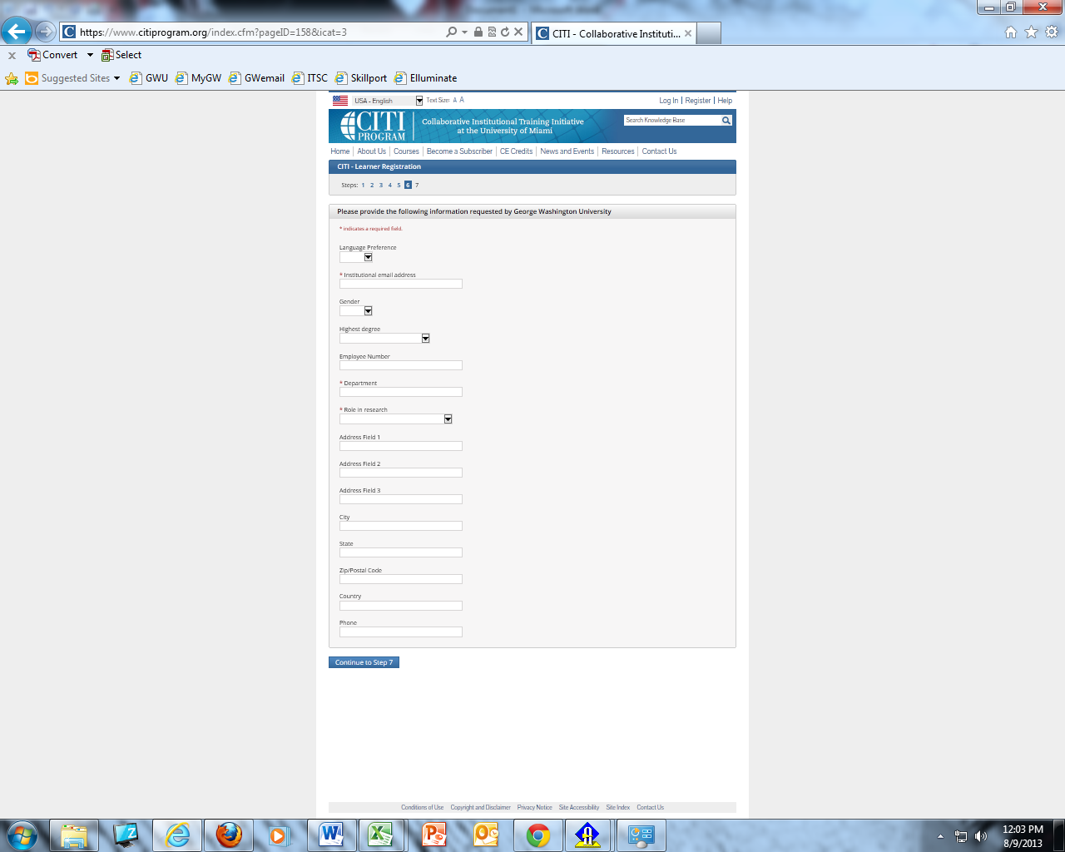

- Choose Human Subjects Research Training
  - Click “NEXT”

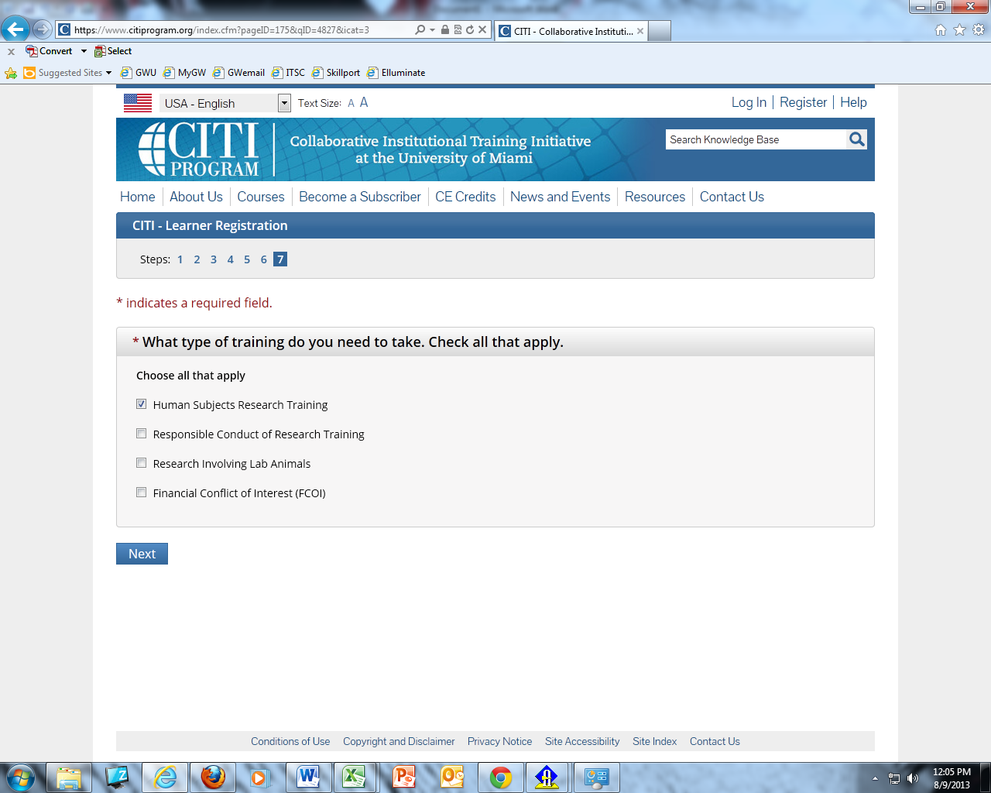

- If this is the first time taking CITI, answer NO in order to take the required basic course(s).

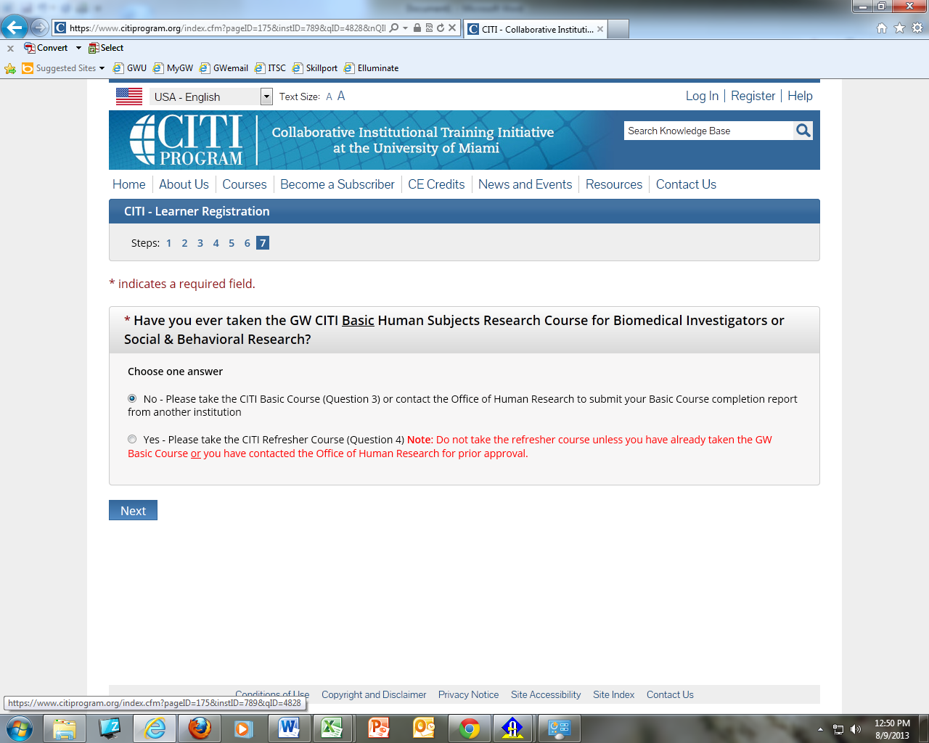

- You will then arrive at this screen and will need to choose the course(s) most appropriate to your research.
  - Generally, this will be either Biomedical Investigators OR Social & Behavioral Research
  - The IRB Members course is for IRB Board members only!
  - Your department may require you to take additional courses. Please be aware, we do not assign these courses and cannot provide information other than the requirements for human subject research.
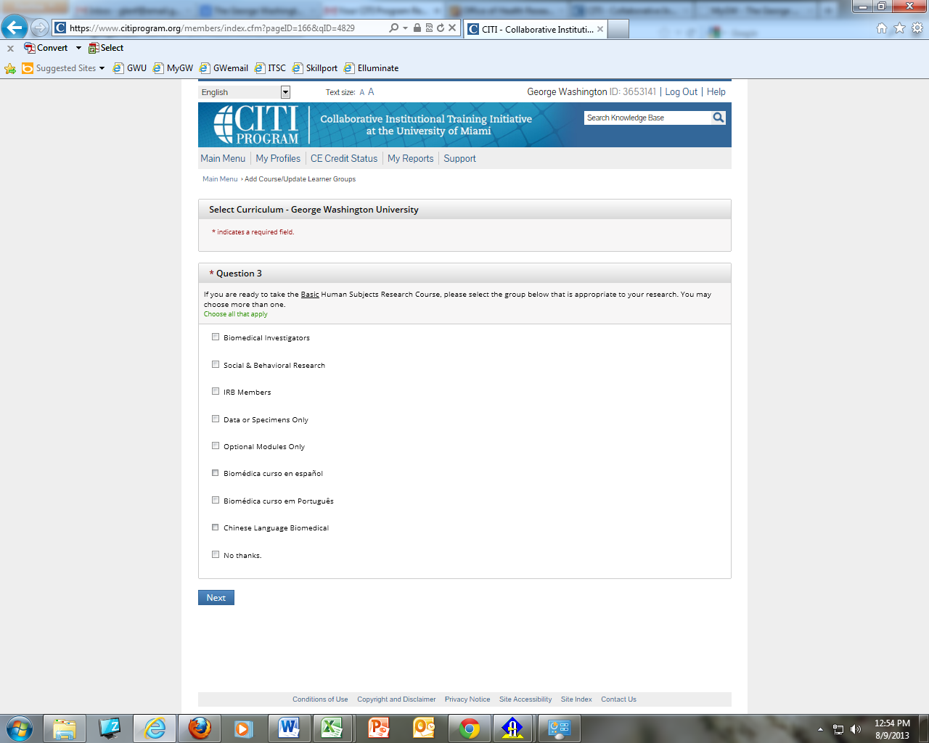
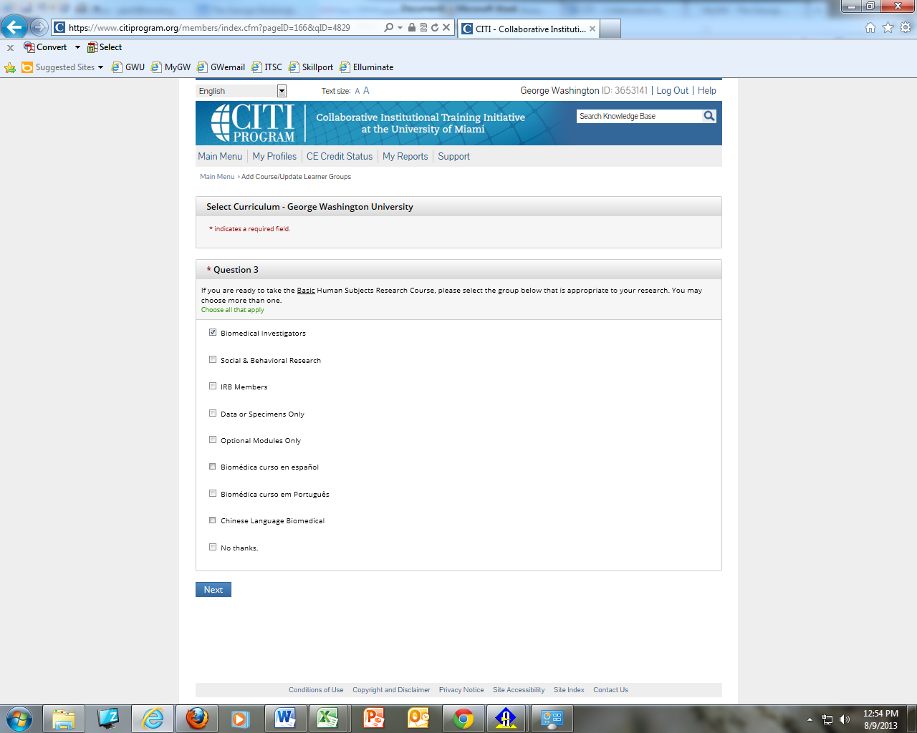
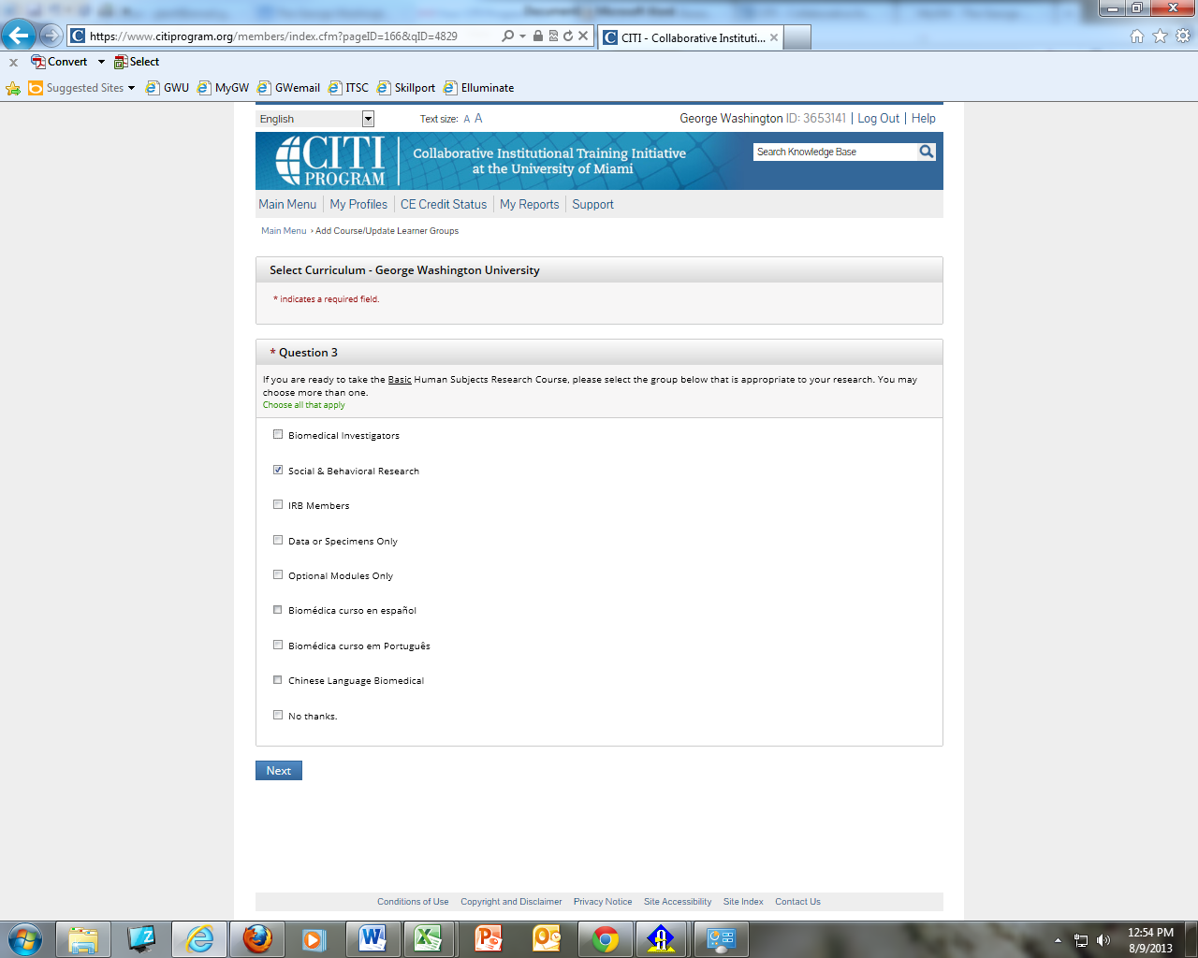

- If you ONLY need to take the HIPS course, choose “No Thanks.”

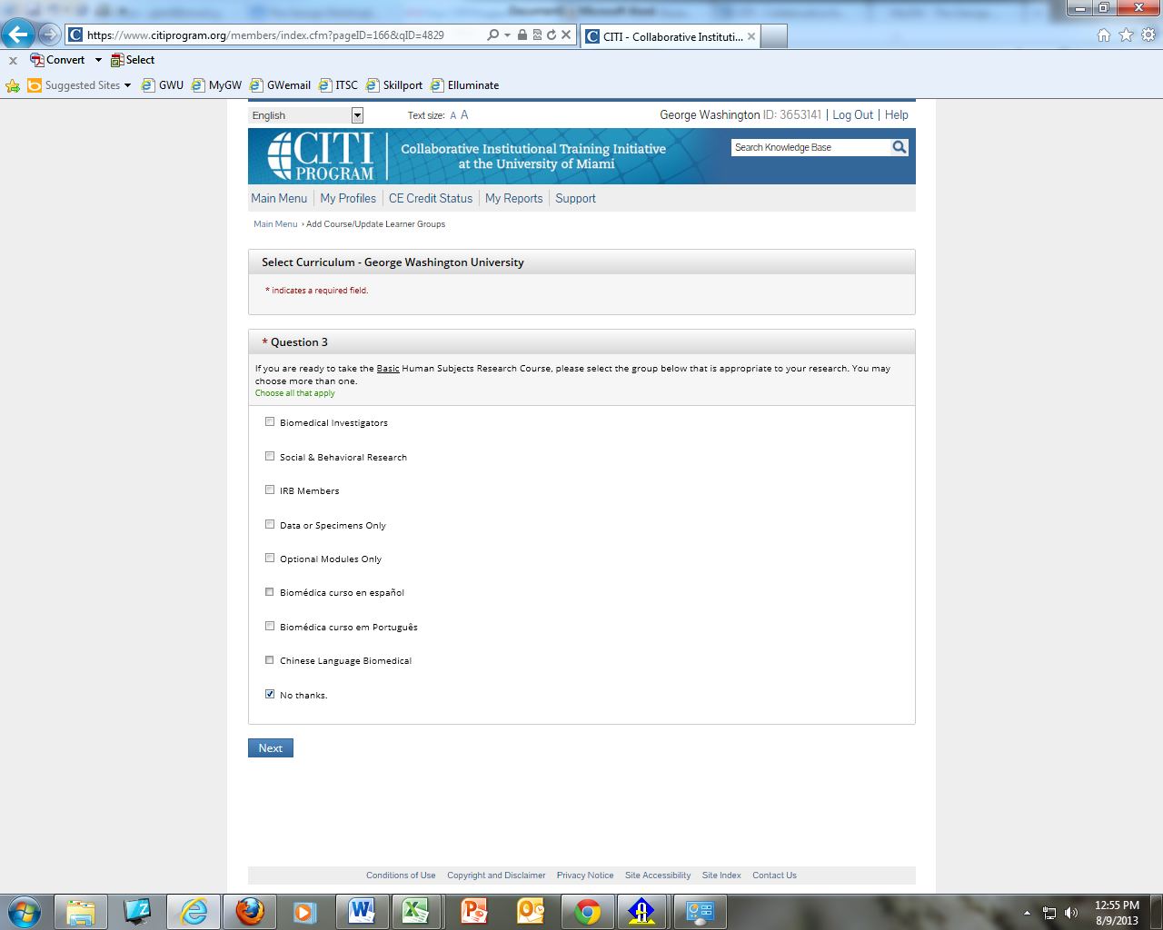

- Click on the HIPS course if you will have access to PRIVATE HEALTH INFORMATION – choose no if you will not have access to such information.
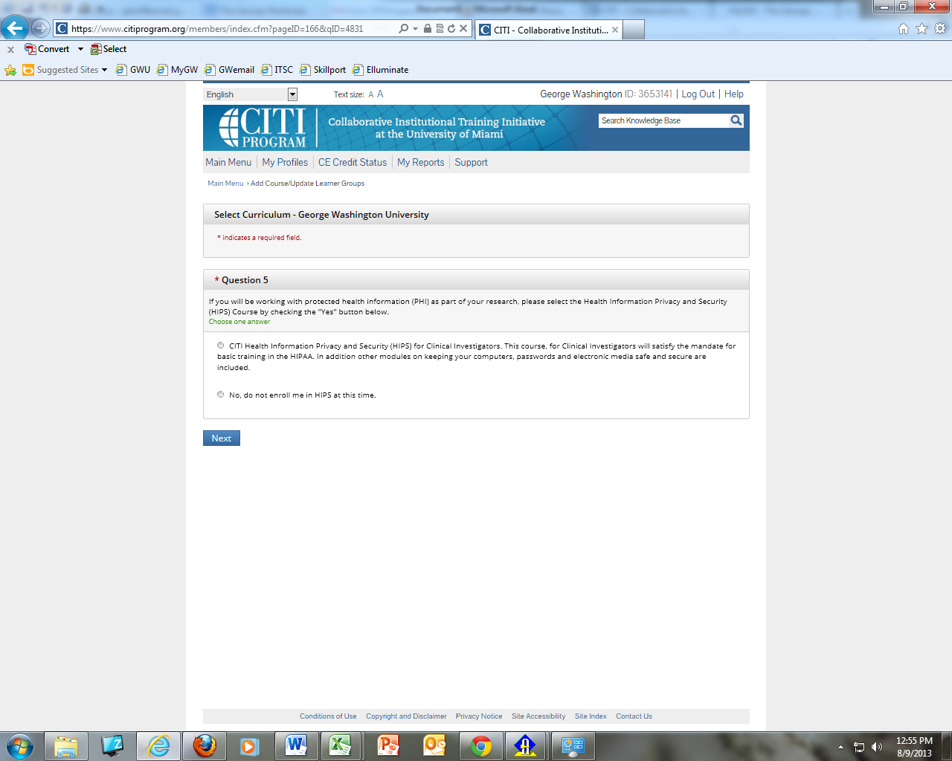

- Answer no to Good Clinical Practice
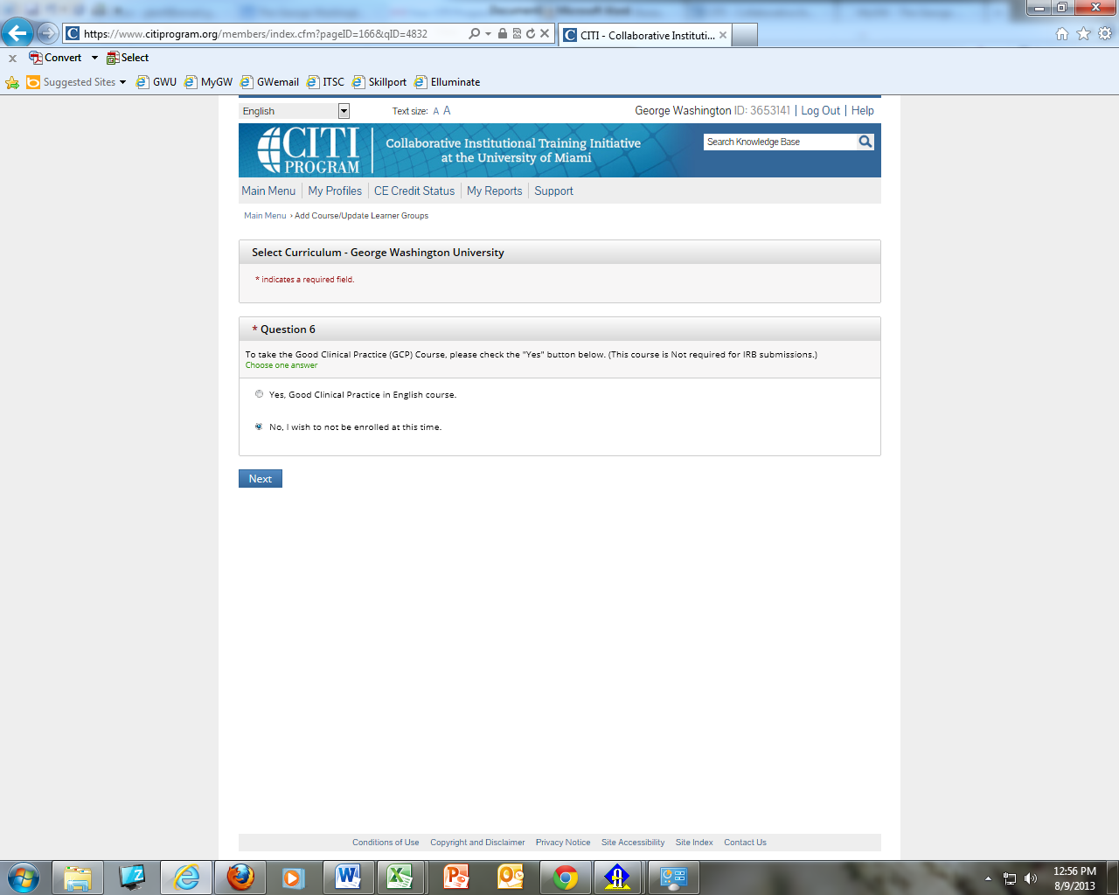

- You will now be back at your account’s home page where you will see the course(s) you’ve selected waiting for you to begin them. You can begin a course and return to it at a later time. Your CITI must be complete and up-to-date for all of your research team before you will be granted IRB approval.
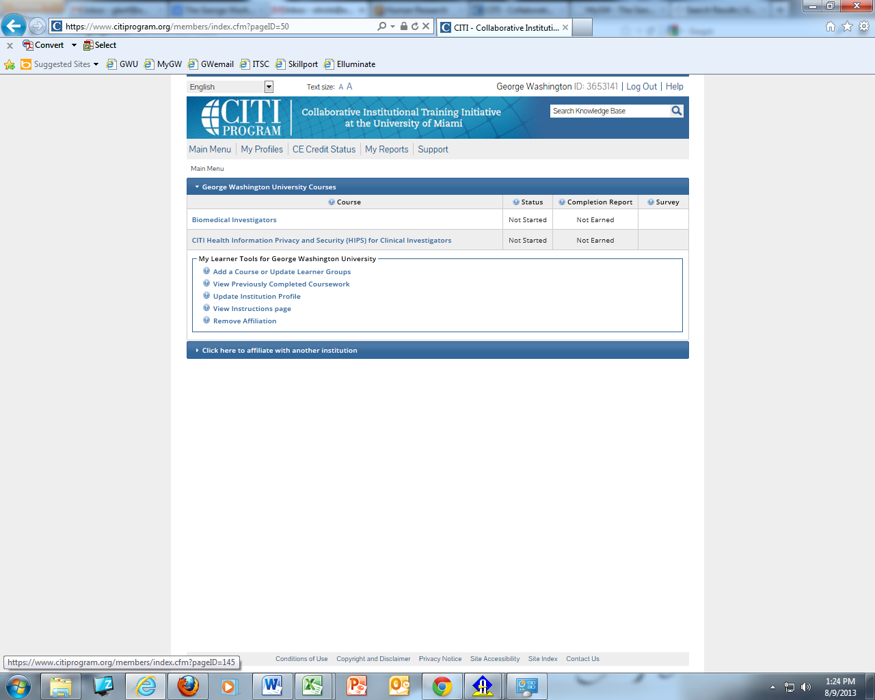

REFRESHER COURSES
- After logging into your account DO NOT CREATE A NEW ACCOUNT! Select “Add a Course or Update Learner Groups”

- Select Human Subjects Research Training

- Select YES to take a refresher course

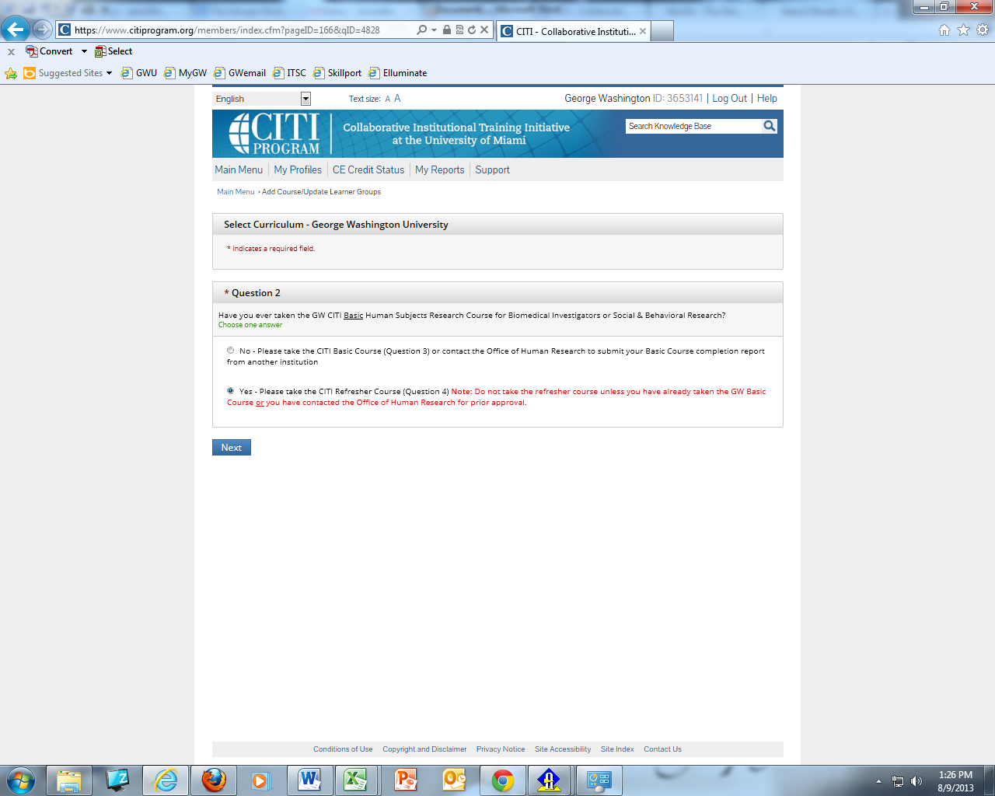

- Select the appropriate course(s) for your refresher(s)
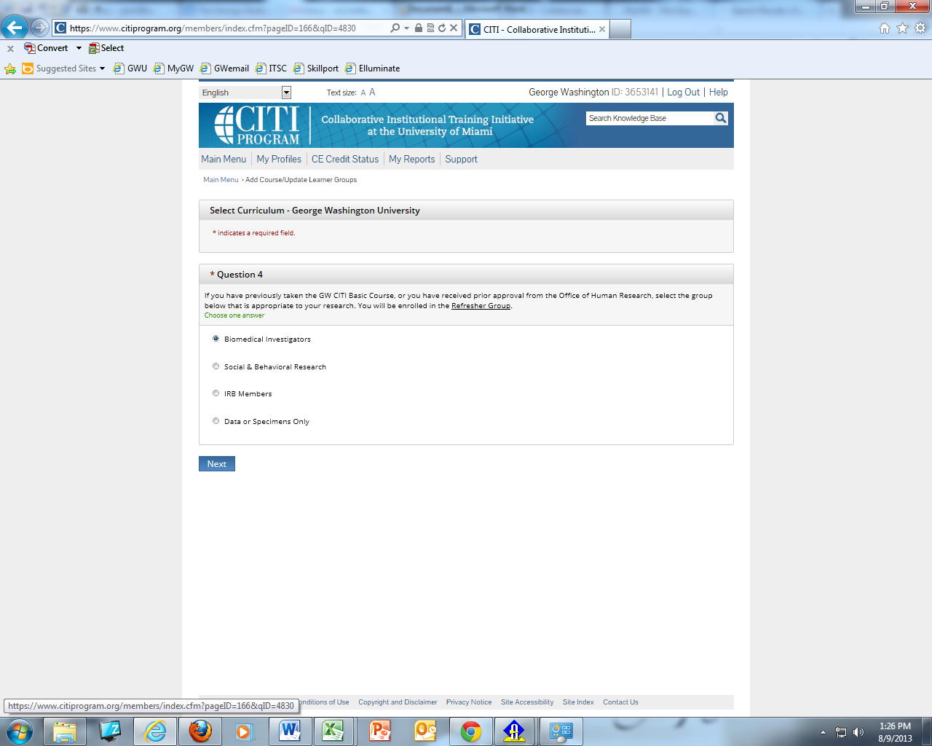
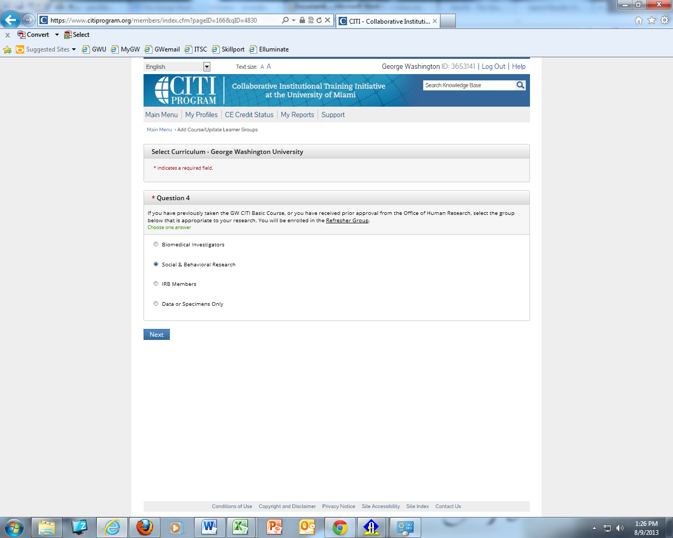

Social & Behavioral Research Biomedical Investigators

TO OBTAIN A COPY OF YOUR COMPLETION REPORT
- To Obtain a copy of your completion report for your or your PI’s records go to Main Menu and select “View Previously Completed Coursework”

- Select the Completion Report(s) needed click on “VIEW”

  - You will note this page also show you the expiration date of each course you have completed.
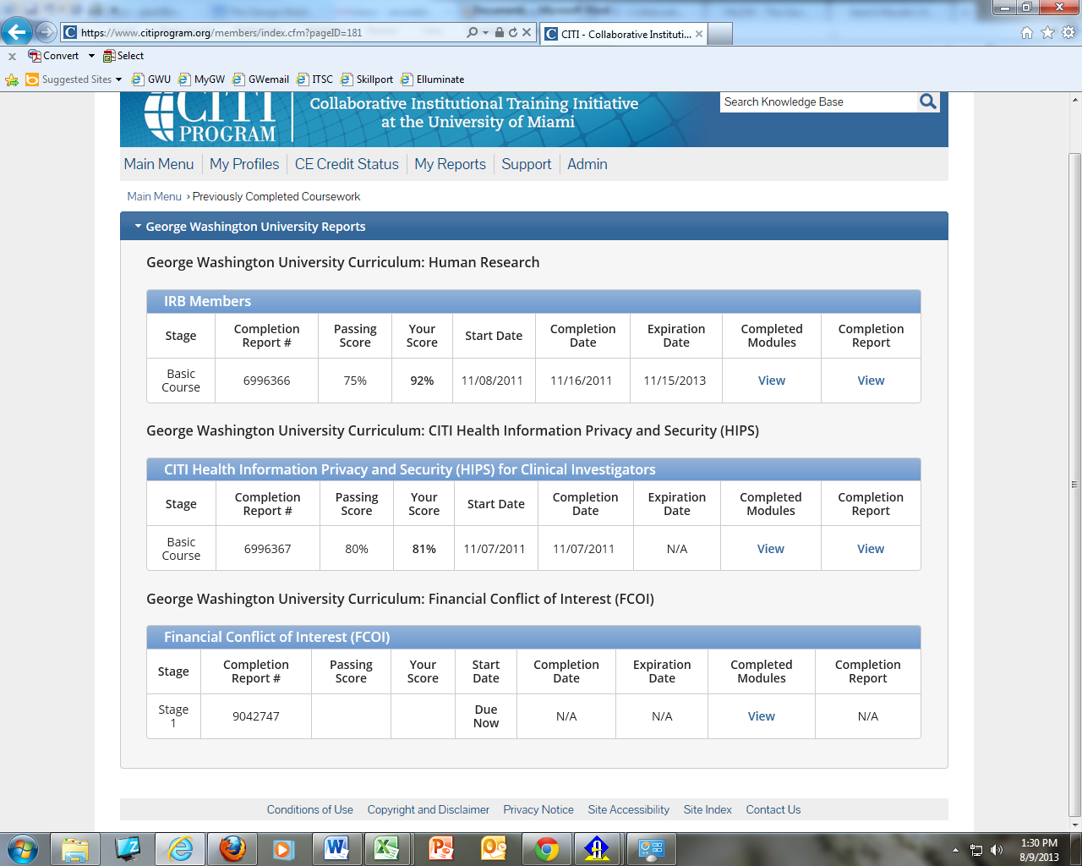

- Once the completion report is opened choose print to print a hard copy and/or save a pdf copy

